Online C/C++ Code Editor – web compiler

**A PROJECT REPORT**

#### Submitted by

Shaik Adam Durwaish (21BCS4222)

#### in Partial Fulfillment of the Requirements for the Degree of

**BACHELOR OF ENGINEERING**

**IN**

COMPUTER SCIENCE



**Chandigarh University**

April - 2025



**BONAFIDE CERTIFICATE**

Certified that this project report “**Online C/C++ Compiler – Web Compiler**” is the bonafide work of “**Shaik Adam Durwaish**” carried out the project work under my supervision.

**SIGNATURE SIGNATURE**

Mr. Aman Kaushik Prof. Ravneet Kaur

**HEAD OF THE DEPARTMENT SUPERVISOR**

AIT-CSE AIT-CSE

Submitted for the project viva-voce examination held on 18/05/24.

**INTERNAL EXAMINER EXTERNAL EXAMINER**

**ACKNOWLEDGEMENT**

We are very pleased to present this report "Online C/C++ Compiler – Web Compiler". We are deeply indebted to our esteemed guide Prof. Ravneet Kaur of Department of Computer Science for his valuable guidance, excellent guidance and constant encouragement throughout the work.

We thank Dr. Aman Kaushik, HOD for giving us an opportunity to present our project. Many thanks to Prof. Ravneet Kaur for his continued interest in the project and helpful suggestions to resolve the issues encountered during the work. We are also grateful to all the other lecturers and officials of the department who have given their valuable support for their friendly cooperation.

We also thank the librarian for providing useful educational material to CU. Last but not the least, we thank our family members, friends and all our well- wishers for their encouragement and moral support during the project work. We thank God Almighty for his best blessings that he showed me in completing this!

**TABLE OF CONTENTS**

List of Figures i

List of tables ii

Abstract iii

Abbreviations iv

Chapter 1: Introduction 10

* 1. Problem Statement 12
     1. Problem Definition 12
     2. Problem Overview 13
  2. Specifications 15
     1. Hardware 15
     2. Software 16

Chapter 2: Literature Survey 18

* 1. Existing System 21
  2. Proposed System 23
  3. Literature Summary Table 26

Chapter 3: Methodology 27

* 1. Problem Formulation 27
  2. Website’s Working 30
     1. User Access 31
     2. User Authentication (Sign Up/Login) 31
     3. User Interaction 32
     4. API Integration and Micronutrient Filtration 33
     5. Data Management 33

Chapter 4: Result analysis and Validation 35

* 1. Use of modern tools 35
  2. Design Testing 39
  3. UI Implementation 43
  4. Research Objective 45

Chapter 5: Future Work and Conclusion 51

* 1. Future scope 51
  2. Conclusion 57
  3. References 59

# LIST OF FIGURES

Figure 1: Flowchart from user access to API Integration 30

Figure 2: Workflow description of the website 34

Figure 3: Homepage of the website 43

Figure 4: Search page for the food items 43

Figure 5: Details of the selected food item 44

# LIST OF TABLES

Table 1: Literature Summary Table 26

# ABSTRACT

In today’s fast-paced digital ecosystem, web-based tools have become increasingly vital for enhancing accessibility and collaboration in programming. Traditional offline compilers require lengthy installations and platform-specific configurations, which can hinder rapid development and learning. This project aims to address those limitations by providing an intuitive and efficient online C/C++ compiler that runs entirely in the browser, making coding possible from virtually any device without the need for a local setup.

The system is built using a modern tech stack comprising **React.js** for the frontend, integrated with **Monaco Editor** for code editing and **Xterm.js** for terminal output. The backend is handled by **Node.js** and **Express**, where user-submitted C/C++ code is compiled and executed in real time through system-level compilers like g++. The platform supports runtime input, which enhances interactivity and allows users to test logic-based and input-dependent programs effectively. To ensure user safety and system integrity, the execution is sandboxed, preventing any malicious access or unintended system calls.

This project demonstrates how web technologies can be combined to deliver a functional development environment for compiled languages like C and C++. It not only serves as a useful tool for students and developers but also showcases the potential of hybrid cloud-based IDEs. With its responsive design and real-time capabilities, the compiler is suitable for educational platforms, coding practice, and technical interviews, especially in remote and cross-platform scenarios.

**Keywords:**

C/C++ Compiler, Online IDE, Web-based Code Editor, Node.js, React.js, Monaco Editor, Xterm.js, Real-time Execution, Code Runner, Sandbox Environment

# ABBREVIATIONS

MERN - MongoDB, Express.js, React.js, Node.js API - Application Programming Interface

UI - User Interface

UX - User Experience

CRUD - Create, Read, Update, Delete JSON - JavaScript Object Notation DBMS - Database Management System REST - Representational State Transfer URL - Uniform Resource Locator HTML - Hypertext Markup Language CSS - Cascading Style Sheets

SQL - Structured Query Language

CDN - Content Delivery Network

HTTPS - Hypertext Transfer Protocol Secure MVC - Model-View-Controller

SSL - Secure Sockets Layer JWT - JSON Web Token

# CHAPTER 1: INTRODUCTION

In the evolving world of software development and programming education, accessibility and ease of use are key to accelerating learning and productivity. Traditionally, C and C++ programs are written and executed using offline tools that require proper setup of compilers and environments, which can be a barrier—especially for beginners and those working on shared or limited-resource systems. Recognizing this challenge, there is a growing demand for browser-based development platforms that eliminate these complexities and offer instant code execution capabilities directly through the web.

Recent advancements in web technologies and cloud computing have made it possible to build real-time code execution environments that function seamlessly in the browser. These platforms promote a more inclusive and flexible approach to coding by allowing users to write, compile, and execute code from any device, regardless of its specifications or installed software. While online IDEs exist for scripting languages like Python and JavaScript, providing a responsive and secure environment for compiled languages like C and C++ presents unique challenges in terms of compilation, runtime input handling, and sandboxing for secure execution.

To address these technical gaps, this report introduces the development of a web-based **Online C/C++ Compiler** built using the **MERN stack (MongoDB, Express.js, React.js, Node.js)** along with **Monaco Editor** and **Xterm.js** for a seamless coding experience. The platform enables users to write C/C++ code, provide runtime input, and view real-time terminal output—all within the browser. Code is sent to the server, compiled using system-level compilers (gcc/g++), and the results are displayed back to the user with minimal delay. This project outlines the overall system architecture, security considerations, and technical implementation while highlighting the project's potential to serve as an educational tool, a practice environment for programmers, and a foundation for future development of full-scale online IDEs for compiled languages.

By combining real-time capabilities with a user-friendly interface, the Online C/C++ Compiler bridges the gap between traditional development environments and the need for accessible, modern coding solutions. Its design emphasizes simplicity, speed, and reliability, making it ideal for both learning and practical use. As coding becomes an essential skill across disciplines, tools like this play a crucial role in democratizing programming access, reducing entry barriers, and enabling a smoother transition for beginners into the world of system-level languages like C and C++.

## PROBLEM STATEMENT

### Problem Definition

Maintaining a balanced micronutrient intake is crucial for overall health, yet many people face challenges in monitoring and achieving optimal levels of essential vitamins and minerals. Micronutrients like vitamin D, iron, magnesium, and zinc play vital roles in immune function, energy metabolism, and disease prevention, but inadequate or excessive intake can lead to health issues. Existing diet-tracking tools often lack comprehensive features for tracking these nutrients, focusing primarily on macronutrients (carbohydrates, proteins, fats) instead. This lack of detail in micronutrient tracking prevents users from effectively managing their intake and understanding nutrient gaps in their diets, leaving a significant gap in current nutrition management solutions.

Moreover, the popularity of high-dose vitamin supplements has led to increased consumption without adequate monitoring or understanding of potential risks. Studies, especially those focused on HIV patients undergoing highly active antiretroviral therapy (HAART), have shown that high-dose vitamin supplementation does not yield improvements in health outcomes compared to standard doses and may, in fact, pose risks by increasing liver enzyme levels and other markers of toxicity. This highlights a broader issue where synthetic supplements are often used as a quick remedy for nutrient deficiencies, potentially neglecting the benefits of natural nutrient sources and balanced intake.

Addressing these gaps requires a tool that not only provides detailed micronutrient tracking but also educates users on sourcing nutrients from natural, whole foods and encourages balanced intake rather than reliance on supplements.

### Problem Overview

Despite the availability of various diet-tracking applications, most of these platforms fail to offer detailed tracking for micronutrients. While users can accurately track calories and macronutrients, they often receive limited insights into their vitamin and mineral intake. For individuals seeking a holistic view of their diet, such as those managing specific health conditions or pursuing preventative health strategies, this lack of micronutrient focus leaves a substantial unmet need. Without precise information on micronutrient intake, users may unknowingly overlook deficiencies or over-consume certain vitamins and minerals, leading to potential health complications over time.

Further complicating this issue is the growing reliance on synthetic supplements, which are widely marketed as convenient solutions for nutrient deficiencies. However, clinical findings caution against high-dose vitamin supplementation, particularly in patients with chronic conditions. For example, research on HIV patients undergoing HAART therapy found that excessive vitamin doses did not improve disease progression or reduce mortality risk compared to standard doses, instead increasing potential health risks by elevating liver enzyme levels. This points to the need for a balanced, food-based approach to micronutrient intake, which is often overlooked by current tools that either lack educational content or fail to promote nutrient-dense whole foods over synthetic options.

The goal of this project is to develop an advanced, user-friendly vitamin tracking application that fills these gaps. By providing accurate, real-time data on both macronutrients and micronutrients, users can gain a comprehensive understanding of their dietary patterns. The app will include personalized nutrient intake recommendations based on users’ unique profiles and dietary preferences,

offering targeted guidance on how to achieve balanced nutrient intake naturally. Moreover, the app emphasizes the importance of sourcing nutrients from whole foods rather than relying on synthetic supplements, supporting a more sustainable and long-term approach to dietary health.

In addition to tracking and recommendations, the application will educate users on the benefits of natural nutrient sources, guiding them to make informed, health- promoting dietary choices. This holistic approach not only empowers users to monitor their diet effectively but also fosters greater awareness of how natural nutrition contributes to long-term wellness, addressing the root causes of nutrient imbalances in a sustainable way. Through these comprehensive features, the project aims to create a tool that not only monitors micronutrient levels but also supports users in building healthier dietary habits and reducing dependency on synthetic supplementation.

## SPECIFICATIONS

* + 1. **Hardware Specifications**

To ensure the smooth development, testing, and deployment of the vitamin tracking application, the following hardware components are used by us:

* + - 1. Development Machine:
         * Processor: Intel i5 or higher / AMD Ryzen 5 or higher
         * RAM: 8 GB minimum (16 GB recommended for handling multiple applications simultaneously)
         * Storage: SSD with at least 256 GB for faster performance
         * Graphics: Integrated graphics are sufficient for basic web development; however, a dedicated GPU may be beneficial for handling data visualization tools.
         * Network: Reliable internet connection for API integrations, data retrieval, and deployment
      2. Server Specifications:
         * Processor: Intel Xeon or equivalent for handling multiple requests and ensuring faster response times
         * RAM: 16 GB or more to handle concurrent user activity efficiently
         * Storage: 500 GB SSD for database storage and scalability
         * Network: High-speed network with redundancy to ensure minimal downtime for users
    1. **Software Specifications**

The software stack for this project is composed of both backend and frontend components, alongside additional tools for version control, testing, and deployment.

* + - 1. Operating System:
         * Development Environment: Windows 11
         * Server Environment: Linux (Ubuntu Server 20.04 or higher recommended for stability and security)
      2. Development Tools:
         * Code Editor: Visual Studio Code (VS Code) for efficient code writing and debugging, with extensions for Node.js and React.js
         * Version Control: Git for tracking code changes, with GitHub as the repository host
         * Testing Tools: Postman for API testing; Jest and Mocha for unit and integration tests
      3. Frontend:
         * React.js: JavaScript library for building interactive UI components and managing state
         * HTML5 and CSS3: For basic structure and styling of the application interface
         * Bootstrap or Material-UI: For responsive, user-friendly component design
      4. Backend:
         * Node.js: JavaScript runtime environment for building scalable server-

side applications

* + - * + Express.js: Web framework for managing server operations and API endpoints
      1. Database:
         * MongoDB: NoSQL database for efficient data storage and quick retrieval of user data, nutritional content, and reports
         * Mongoose: Object Data Modeling (ODM) library for MongoDB to define schemas and interact with MongoDB seamlessly
      2. External APIs:
         * Nutrition APIs: To retrieve accurate, real-time nutritional information for various foods
         * Authentication APIs: For secure user authentication (e.g., OAuth for social logins)
      3. Deployment:
         * Hosting: Cloud services like Heroku, AWS, or DigitalOcean for reliable, scalable deployment of the application
         * Continuous Integration/Continuous Deployment (CI/CD): GitHub Actions for automated testing and deployment

These specifications provide a robust foundation for the vitamin tracking application, supporting efficient development, user-friendly interface, and secure, scalable deployment.

# CHAPTER 2: LITERATURE SURVEY

Tracking and managing daily micronutrient intake have become increasingly relevant as public awareness of the importance of balanced nutrition grows. Several studies have demonstrated the critical role vitamins and minerals play in overall health, influencing everything from immune function to cognitive performance and chronic disease prevention. However, despite widespread awareness, many individuals struggle to meet their daily micronutrient needs due to poor dietary habits, lack of knowledge, or reliance on processed foods. This gap highlights the need for tools that help individuals monitor and improve their nutrient intake through more natural food sources.

For instance, research by Drishti Ghelani and colleagues highlighted the increasing use of mobile apps in weight management. Mobile-based dietary interventions have proven helpful, though their long-term efficacy is still under debate. These apps often serve as adjuncts to conventional methods of weight control, making nutrition tracking easier and more accessible for users [2]. Cronometer, a popular micronutrient tracking app, offers features for personalized nutrition based on user profiles. It has expanded its capabilities to track immunity and women’s health, providing users with tailored nutritional insights. This approach aligns with trends toward personalized health management, driven by user-specific needs [3]. The first source is a research article that assesses the functionality and precision of seven widely used diet-tracking smartphone apps. It concludes that while these apps generally excel in ease of use and accurately track calories and carbohydrate intake, they exhibit inconsistencies when recording protein and fat consumption. The second source is a clinical summary of a study focused on high-dose vitamin supplementation in HIV patients undergoing highly

active antiretroviral therapy (HAART). The study reveals that taking high doses of vitamins does not lead to improved disease outcomes or reduced mortality compared to standard doses. In fact, it may raise liver enzyme levels, suggesting potential adverse effects [4].

Another analysed 80 food consumption tracking and recommendation apps from major app stores, using a rating tool to evaluate their features, functionality, and software quality. Key aspects assessed included aesthetics, usability, performance, transparency, and perceived impact. The review found that most apps were lacking in automation, requiring users to manually input food data, which made tracking cumbersome. Additionally, the food databases in many apps were incomplete, with limited coverage of international and region-specific foods. While a few apps could recognize food from images, their accuracy and scope were limited. The study also noted the lack of expert dietitian or nutritionist involvement in app development, leading to a deficiency in evidence-based recommendations, which is critical for ensuring the accuracy and credibility of dietary advice. The authors recommend improvements, such as using deep learning algorithms to automate food recognition, volume estimation, and personalized recommendations. They also suggest expanding food databases to provide a more comprehensive range of items from different regions, enhancing user experience through better interface design, and improving app performance and transparency. Overall, the review highlights the potential of these apps to support healthier dietary habits but emphasizes the need for significant improvements to make them more effective [5].

Health is a dynamic, ever-changing concern across all age groups. A healthy diet, especially in today’s fast-paced lifestyle, involves consuming essential nutrients from all food groups and drinking enough water to maintain health. A balanced diet should meet a person’s metabolic and activity needs without excessive calorie intake. Another project aims to develop an Android-based mobile

website that helps users, particularly college students, track their daily food intake and monitor their calorie and nutrient consumption through graphical representations. Given Android’s 84.7% global smartphone market share, the app is developed for Android, using Android Studio 2.1.3 and Java JDK Version 1.7, to create a user-friendly experience [6].

Garcia’s research paper investigates the potential for a personalized nutrition knowledge-based system called “Virtual Dietitian” to address nutrition challenges among Filipino young adults. The study utilized a mixed-methods approach, including focus groups and an online survey, to understand the needs and preferences of this target population. The results revealed that many Filipino young adults lack sufficient nutrition knowledge, do not track their food intake, and are often influenced by family preferences and limited access to affordable and healthy food options. However, the study also found a strong willingness among participants to embrace a healthier lifestyle through the use of technology. Based on these findings, the researchers propose a functional architecture for “Virtual Dietitian,” which includes features such as a meal planner, food tracker, recipe analyzer, grocery list, nutrition history, and progress report. The researchers argue that such a tool could serve as a valuable nutrition intervention tool, helping individuals make informed food choices, track their progress, and achieve their health goals [7].

# EXISTING SYSTEM

Existing vitamin tracking and diet management applications have grown significantly in popularity, each providing distinct features to cater to different health and dietary needs. Below is an exploration of some key existing concepts and projects that address aspects of micronutrient tracking and personalized dietary recommendations.

* + 1. **General Diet and Calorie Tracking Apps**

Applications like **MyFitnessPal**, **Cronometer**, and **Lose It!** are among the most widely used diet-tracking apps. They focus primarily on calorie counting and macro-tracking (proteins, fats, and carbohydrates) while offering some level of micronutrient tracking. **MyFitnessPal** allows users to log food intake, track basic micronutrients, and set daily goals. However, it generally emphasizes weight management over holistic nutrient tracking, which may limit its depth in vitamin and mineral analysis **Cronometer** distinguishes itself by offering detailed micronutrient tracking, covering a broad range of vitamins and minerals. It’s particularly popular with users who are more health-focused and interested in monitoring the quality of their nutrient intake, yet it may be overwhelming for users seeking a more streamlined experience.

* + 1. **Age-ment Apps for Specific Conditions**

Some applications specifically target users with chronic health conditions, offering tailored dietary suggestions to support specific medical needs. For instance, **CareClinic** provides symptom tracking and supplement reminders for patients with conditions requiring strict dietary control, such as diabetes or cardiovascular issues. Additionally, apps focused on **HIV patient support** offer monitoring for patients undergoing treatments like HAART (Highly

Active Antiretroviral Therapy), as studies have highlighted the importance of nutrient management in improving these patients' quality of life.

* + 1. **Vitamin Tracking Apps**

Applications like **VitaTrackr** and **My Vitamins** are designed specifically for vitamin and supplement tracking. These apps help users monitor their intake of supplements and suggest dosages based on general health recommendations. However, many of these platforms focus on synthetic supplements rather than encouraging natural sources of nutrients, which limits their use for individuals seeking whole-food-based nutrient tracking.

* + 1. **Wearable Devices Health Platforms**- **Wearable technology**

These include **Fitbit** and **Apple Health** has advanced to track various health metrics, including heart rate, activity levels, and, in some cases, general diet. These devices integrate with other health apps to create a more holistic health profile. However, they often lack comprehensive micronutrient tracking, which limits their use for users who specifically want to monitor their intake of essential vitamins and minerals.

* + 1. **Emerging AI-Powered Nutritio**

Recently, **AI-powered nutrition platforms** like **Foodvisor** and **Suggestic** have been gaining traction. These apps use AI to analyze meals and generate nutritional information through photo-based food recognition, allowing for faster food logging and nutrient tracking. They aim to provide personalized dietary recommendations, yet may lack the specificity in micronutrient analysis needed for users focusing on particular vitamins and minerals.

# PROPOSED SYSTEM

The proposed system is a web-based vitamin tracking application developed using the MERN stack (MongoDB, Express.js, React.js, Node.js) that aims to provide users with a holistic, intuitive tool for monitoring their daily micronutrient intake. Unlike many existing systems that focus primarily on calorie counting or macronutrient tracking, this application is designed with an emphasis on vitamin and mineral intake, providing real-time, data-driven insights into users’ dietary habits. Below are key features and functionalities of the proposed system, followed by a discussion of how it addresses the existing gaps identified in current solutions.

1. **User-Friendly Interface for Daily Tracking**
   * The application provides an intuitive user interface that simplifies the process of logging daily food intake. By using React.js on the frontend, the platform ensures a responsive and interactive user experience, allowing users to quickly and easily enter their meals and snacks throughout the day. Each food item logged is cross-referenced with a comprehensive nutritional database, automatically calculating the levels of key vitamins and minerals consumed.
   * This approach contrasts with many existing platforms, which can be overwhelming with complex nutrient breakdowns. The proposed system provides streamlined nutrient insights, making it accessible to users who may not be experts in nutrition.
2. **Real-Time Data and API Integration**
   * Leveraging MongoDB as the database and integrating external APIs, the application retrieves up-to-date nutritional information for a wide array of foods. By accessing accurate and current data, the system offers users a

reliable source of information on micronutrient content, which is essential for making informed dietary choices.

* + Real-time API integration is particularly beneficial in ensuring that the app’s nutritional information remains relevant, addressing a common limitation of static, outdated databases seen in many conventional diet apps.

1. **Personalized Nutrient Reports and Recommendations**
   * The system generates personalized nutrient reports based on users' logged data, highlighting their intake of essential vitamins and minerals compared to recommended daily values. This feature provides users with insights into any nutrient deficiencies or excesses, enabling them to adjust their diets as needed to achieve balanced nutrition.
   * In addition to tracking, the proposed system offers recommendations focused on natural, whole-food sources of nutrients. Unlike supplement- focused apps, this approach encourages users to fulfill their nutritional needs from food rather than synthetic supplements, promoting a healthier, more sustainable dietary approach.
2. **Promoting Natural Nutrient Sources Over Synthetic Supplements**
   * The application emphasizes sourcing nutrients from natural food sources, educating users about the benefits of whole-food nutrition over synthetic supplementation. This is an essential differentiation from other apps that emphasize supplement intake, and it aligns with research highlighting the health benefits of obtaining vitamins and minerals through natural means.
   * By focusing on food-based nutrients, the proposed system advocates a preventive health approach, encouraging users to consume nutrient-dense foods that not only fulfill micronutrient requirements but also provide other health benefits.
3. **Educational Component and Informed Dietary Choices**
   * Beyond tracking and reporting, the application includes educational resources, such as articles, tips, and food recommendations, to help users understand the role of various vitamins and minerals in their health. This component aims to empower users with knowledge that can lead to long- term health improvements.
   * Many existing diet-tracking apps focus on short-term goals like weight loss, often at the expense of holistic health. By educating users about the importance of balanced micronutrient intake, the proposed system provides a foundation for sustainable dietary changes.
4. **Secure and Scalable System Design**
   * Using Node.js and Express.js on the backend, the proposed system is designed to handle user data securely, ensuring that user privacy and data protection are prioritized. The MERN stack offers scalability, making it suitable for managing a growing user base without compromising performance.
   * Scalability and security measures address the future scope of the application, allowing it to expand to accommodate new features, such as integration with wearable devices or personalized dietitian support, without overhauling the existing architecture.
   1. **LITERATURE REVIEW SUMMARY**

|  |  |  |  |
| --- | --- | --- | --- |
| **Year** | **Authors** | **Paper** | **Technique/Focus** |
| 2022 | A. Scarry, J. Rice, E. M. O’Connor, A.  C. Tierney | Usage of mobile websites or mobile health technology to improve diet quality in adults | Mobile health technology for diet improvement |
| 2020 | D. P. Ghelani et al. | Mobile apps for weight management: A review of the  latest evidence to inform practice | Review of mobile apps for weight  management |
| 2021 | C. Media | Cronometer adds immunity and women’s health to micronutrient tracking app | Mobile app updates for tracking immunity and women’s health |
| 2019 | G. Ferrara, J. Kim, S. Lin, J. Hua, E. Seto | A focused review of smartphone diet-tracking apps: Usability, functionality, coherence with behavior change theory, and comparative validity of nutrient  intake and energy estimates | Review of smartphone diet apps' usability, functionality, and validity |
| 2022 | S. Samad et al. | Smartphone apps for tracking food consumption and recommendations: Evaluating artificial intelligence-based functionalities, features, and  quality of current apps | Evaluation of AI- based functionalities in food tracking apps |
| 2017 | D. Bajaj et al. | Android based nutritional intake tracking website for handheld  systems | Android-based system for tracking  nutritional intake |
| 2024 | M. Garcia, J. Mangaba, A.  Vinluan | Towards the Development of a Personalized Nutrition Knowledge-Based System: A Mixed- Methods Needs Analysis  of Virtual Dietitian | Development of a personalized nutrition knowledge system |

# CHAPTER 3: METHODOLOGY

# PROBLEM FORMULATION

In developing a comprehensive micronutrient tracking website, several methodological steps are essential to ensure accurate nutrient monitoring, user engagement, and scalability. The core objective of the project is to create an intuitive web application that provides users with a detailed analysis of their daily micronutrient intake. This involves the development and integration of secure, scalable, and interactive features aimed at enhancing the user experience and delivering reliable dietary recommendations.

**Key Methodological Steps in Problem Formulation**

1. **User Access and Secure Authentication**

Security is foundational in any health-tracking application, as sensitive dietary and health-related data are involved. For this project, secure user authentication protocols are implemented using Node.js and Express.js, along with libraries like Passport.js or JSON Web Tokens (JWT). These tools ensure that user data is protected, providing secure access only to authenticated users. This not only complies with data privacy standards but also fosters user trust, as they can rely on the security of their information within the app.

1. **User Interaction Through API Calls**

To enhance the user experience, the application is designed with an interactive front end using React.js. The UI allows users to log food items,

view detailed reports, and receive nutritional recommendations. The platform utilizes custom API calls for handling food entries, data retrieval, and interaction with the nutritional database. These custom calls enable a smooth data flow, connecting the user’s input on the frontend to backend data processing. The API-driven architecture also allows scalability, supporting additional features like integration with wearable devices or external dietitian support.

1. **Integration with Third-Party Nutrition APIs**

A key aspect of the application’s value is the integration with external nutrition databases via APIs. By connecting with established databases like the USDA Food Database, the application retrieves real-time, accurate information on the nutritional content of various foods. This allows for the tracking of essential micronutrients and makes the app suitable for users aiming to closely monitor their vitamin and mineral intake. The external API integration is particularly beneficial for ensuring that data remains current without needing manual updates to the internal database, thus saving resources and ensuring accuracy.

1. **Data Management and Storage Using MongoDB**

MongoDB serves as the database for storing user logs, food entries, and personalized reports. Its flexibility allows for efficient storage of semi- structured dietary data, and it can easily scale as the user base grows. MongoDB’s ability to handle large amounts of data makes it suitable for storing the numerous data points generated by users’ daily logs, enabling fast access and retrieval of information for data analysis and report generation. Data management strategies, including indexing and data caching, further enhance performance, providing users with near-

instantaneous responses to their queries.

1. **Real-Time Data Visualization and Reporting**

Providing users with actionable insights requires real-time data visualization capabilities. React.js and associated charting libraries (e.g., Chart.js or D3.js) are used to visually represent nutrient consumption patterns. Real-time visual feedback helps users understand their daily, weekly, or monthly nutrient intake trends and identify any deficiencies or imbalances. This level of interactivity is essential for engaging users, making the app not just a logging tool but also an analytical resource that can inform dietary choices.

1. **Personalized Notifications and Recommendations**

To support users in making informed dietary decisions, the app offers personalized notifications based on their dietary patterns and goals. By analyzing the logged data, the system identifies deficiencies or excessive nutrient intake, sending tailored recommendations to help users improve their diet. The personalization engine leverages predefined thresholds for each micronutrient and assesses user data in real-time, enhancing the app’s role as a proactive dietary guide.

1. **Quality Assurance and Usability Testing**

Before deployment, rigorous quality assurance testing is performed to ensure the system’s robustness, accuracy, and usability. Usability testing focuses on assessing how easily users can navigate the platform, log data, and access their nutritional reports. Furthermore, accuracy tests validate the precision of the nutritional data provided, comparing outputs against reliable sources to verify correctness. These testing phases are critical for identifying potential usability issues and ensuring that the application provides reliable and valuable information to users.

# WEBSITE’S WORKING

The micronutrient tracking website functions as a comprehensive tool to help users monitor their daily intake of essential vitamins and minerals, promoting a balanced and nutrient-rich diet. Built on the MERN stack (MongoDB, Express.js, React, Node.js), the website begins with secure user access and authentication, allowing users to create accounts and log in. Through an intuitive React-based interface, users can log meals and food items, which the system uses to calculate the nutrients consumed. The backend, powered by Node.js and Express.js, processes these entries and communicates with MongoDB to store and retrieve user data securely. For precise nutritional analysis, the website integrates with external nutrition APIs, fetching real-time data on the nutrient content of logged foods. This data is then displayed in personalized reports and visualizations, enabling users to track trends, identify deficiencies, and make informed dietary adjustments. The system also delivers tailored notifications and recommendations, further guiding users toward healthier choices. By focusing on accuracy, real-time feedback, and ease of use, the website provides a valuable resource for users seeking to optimize their nutrient intake naturally.

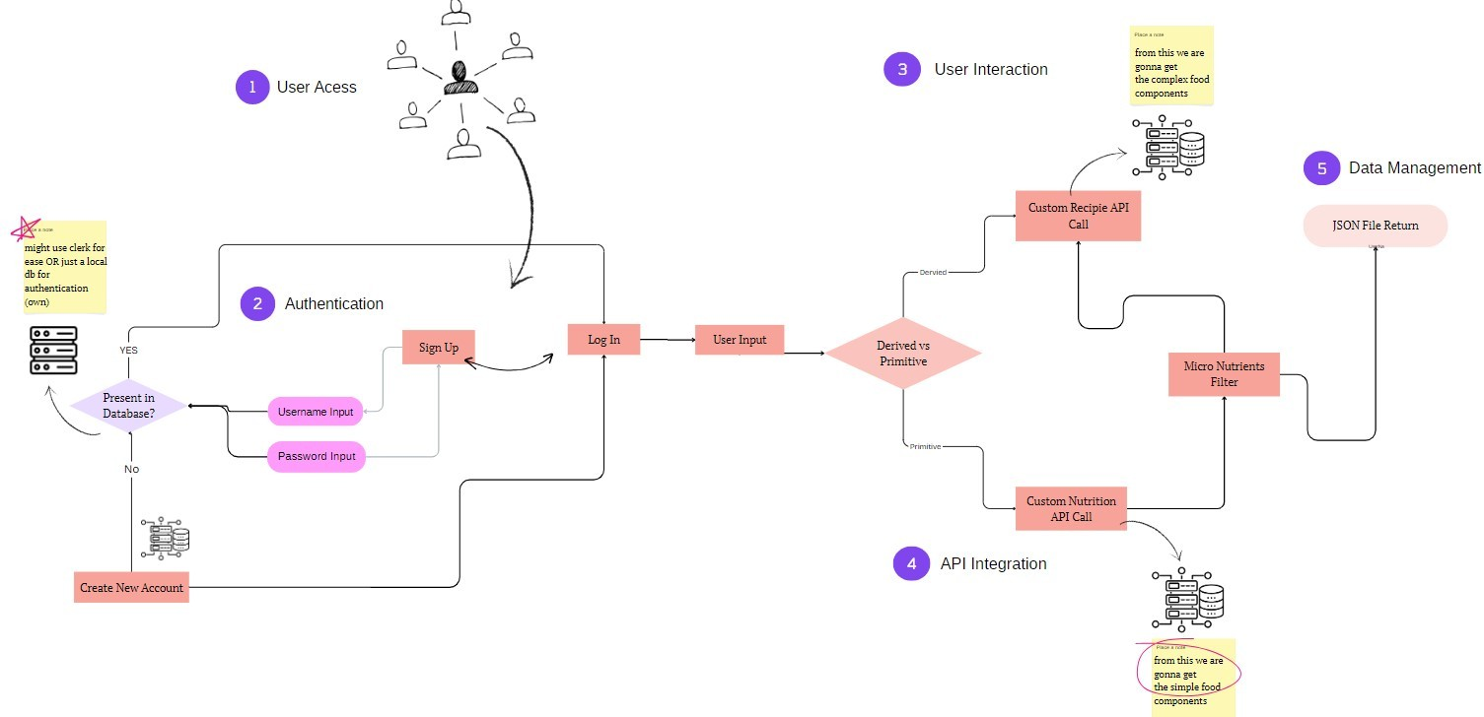

*Fig 1: Flowchart from user access to API Integration*

### User Access

The user begins their interaction with the micronutrient tracker website through any standard web browser. The front end of the application is developed using React, a powerful JavaScript framework known for its ability to create dynamic and responsive interfaces. React’s component-based structure allows the application to load quickly, adapt seamlessly to various devices, and maintain smooth functionality across desktops, tablets, and mobile devices. This choice enhances user experience by providing a unified, intuitive interface with minimal latency. With React’s built-in state management and reusable components, users experience a cohesive and consistent interface that responds dynamically to their actions, making it ideal for users focused on daily tracking activities.

### User Authentication (Sign Up/Login)

The application employs a secure user authentication system to protect sensitive data and ensure privacy. During the sign-up and login process, the user's credentials (like passwords) are encrypted using bcrypt hashing, which generates a unique hash that is stored in MongoDB. This encryption method ensures that even if the database were compromised, the sensitive information remains secure. When users log in, a JSON Web Token (JWT) is generated and sent to the user, allowing for secure, session-based authentication without the need to re-enter credentials repeatedly. JWTs allow secure, token-based access to resources, and all subsequent API requests use this token to verify user identity, maintaining secure, personalized interaction while protecting sensitive user data from exposure.

### User Interaction

After successful authentication, users can access various functionalities aimed at simplifying and personalizing their dietary tracking experience. Key features include:

* + - * Custom Recipe API Call: This feature allows users to input their own recipes, which are then sent to an external nutrition API via HTTP requests. The API processes the ingredients in the recipe and returns a comprehensive breakdown of nutrients, offering users an understanding of the specific vitamin and mineral content in their homemade meals.
      * Custom Nutrition API Call: Users can input specific food items to retrieve real-time nutritional information from the nutrition API. This information includes details on calorie content, macronutrients, and micronutrients, enabling users to see an in-depth analysis of each item’s contribution to their daily intake.
      * User Input: The application provides flexibility for users to enter food data in various ways. They can manually log individual ingredients or select predefined meal options from a library. This flexibility makes the app adaptable to different dietary needs and habits.
      * Derived vs. Primitive Input: Users can log their food intake in two ways: by inputting “primitive” (individual ingredients like spinach or chicken) or “derived” (full meals like lasagna or smoothies). Each entry is analyzed to give an accurate nutritional breakdown, enabling detailed, flexible logging that accommodates diverse meal compositions.

### API Integration and Micronutrient Filtration

The application integrates with third-party nutrition APIs using asynchronous HTTP requests via Axios, a JavaScript library that supports HTTP requests to fetch nutritional information. Once the data is received, a filtration process parses the response to extract micronutrient details such as vitamins and minerals, ensuring accurate nutrient categorization for each food item logged. By isolating micronutrients from macronutrient data, the application can deliver more precise information to users focused on tracking specific vitamins and minerals. This filtration mechanism is essential in ensuring that users receive clear, relevant feedback on their nutrient intake and avoid overloads of unnecessary data.

### Data Management

* + - * Data management in the application is structured to provide seamless storage, retrieval, visualization, and actionable insights based on user input. The main data management functionalities include:
      * Micronutrient Tracking: The application stores all user-entered data in MongoDB through Mongoose, a MongoDB object modeling tool for Node.js, which ensures efficient, schema-based data handling. This setup allows the app to log daily intake for each tracked micronutrient, building a historical dataset that users can access for long-term dietary insights and progress tracking.
      * Data Visualization (Pie Chart): To simplify data interpretation, the application employs charting libraries such as Chart.js or D3.js for visual representation. Real-time pie charts provide users with an overview of their micronutrient intake, giving a visual breakdown that highlights nutrient distribution and shows users at a glance which areas they may need to adjust in their diet.
      * User Notification System: The application sends timely reminders and notifications to users regarding their nutrient intake. Built with Node.js and utilizing cron jobs, this system is configured to alert users to deficiencies or potential overconsumption. By regularly monitoring the user’s data, the system can issue specific reminders to help users maintain balanced dietary habits.
      * 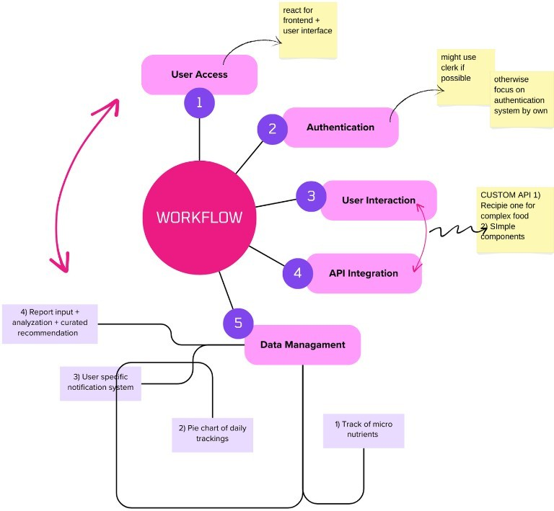Report Generation, Analysis, and Recommendations: The backend processes stored data to generate in-depth reports that analyze users’ intake patterns over time. These reports are presented via the React frontend and incorporate recommendations derived from statistical analysis and dietary guidelines. The recommendations are generated by comparing users’ data with established nutritional standards, suggesting dietary adjustments to help users achieve a balanced nutrient intake. The reports not only present data but provide actionable insights that empower users to make informed, health-conscious decisions.

*Fig 2: Workflow description of the website*

**CHAPTER 4:**

**RESULT ANALYSIS AND VALIDATION**

# USE OF MODERN TOOLS

Modern tools have transformed the development of digital health applications, making the micronutrient tracking project possible with the MERN stack, third- party APIs, secure data protocols, and advanced data visualization libraries. Each tool serves a specific purpose, collectively enabling a feature-rich, user-centered platform that addresses modern nutritional needs through technology-driven solutions.

At the core of the project is the **MERN stack** (MongoDB, Express.js, React.js, and Node.js), which brings together robust backend and dynamic frontend capabilities. React.js, chosen for its component-based structure, provides an efficient way to develop a responsive interface with reusable components. This framework enables a modular approach, ensuring that each element of the user interface functions independently, which is essential for complex applications with varied user inputs. Users benefit from React’s speed and efficiency, as its virtual DOM allows for rapid updates without the need to refresh the entire page, a crucial feature for real-time applications.

On the backend, **Node.js** and **Express.js** power the server operations, handling API calls, managing user requests, and facilitating secure data flow between the client and server. Node.js is chosen for its asynchronous, event-driven structure, which is highly suitable for handling the large volumes of real-time data that nutrition-tracking applications typically involve. Express.js simplifies the configuration and handling of requests by providing essential middleware, routing,

and session management features. This server-side setup supports efficient user authentication and authorization, which is enhanced by the integration of JSON Web Tokens (JWT). With JWT, the application ensures secure, session-based user interactions without constantly revalidating user credentials. This setup enhances data security while providing a seamless user experience, as users are logged in securely without frequent interruptions.

**MongoDB** serves as the application’s database, which is well-suited for projects requiring flexible data structures and rapid access. MongoDB’s NoSQL design allows for efficient data storage and retrieval, especially with unstructured data types common in health and dietary tracking. Using Mongoose as an ORM (Object Relational Mapper) with MongoDB provides the project with schema- based models, making data management more efficient and scalable. For instance, users’ nutrient intake logs can be stored and retrieved quickly, supporting data visualization and personalized feedback. This approach also allows for extensive data analysis by aggregating user information over time, enabling the project to offer insights into dietary patterns and track long-term progress.

To ensure accurate, up-to-date nutritional information, the project integrates **third-party nutrition APIs**. These APIs provide detailed nutrient data, including vitamins, minerals, macronutrients, and caloric content. By leveraging these APIs, the application offers users comprehensive and reliable nutritional information, making it easier for them to track their dietary intake accurately. APIs also facilitate real-time data retrieval, allowing users to access information on new foods and dietary trends as they emerge. The use of Axios, a popular JavaScript library, streamlines the process of making HTTP requests to these APIs. Axios manages asynchronous data handling efficiently, allowing the application to fetch and display nutrition data seamlessly in real time.

**Data visualization tools** like Chart.js and D3.js enhance the usability of the application by presenting nutrient tracking data in an intuitive, visual format. Users can see their daily nutrient intake as pie charts, bar graphs, or other forms of visual representation, which makes it easier to assess their dietary habits at a glance. These tools support the presentation of complex data in a way that is accessible to users, promoting a better understanding of dietary intake patterns. Chart.js offers a variety of chart types, enabling users to choose visual formats that best suit their tracking needs, while D3.js provides customizability and interactivity, creating a more engaging user experience.

For notifications and reminders, **Node.js cron jobs** are used to schedule and send personalized alerts based on users’ tracked nutrient levels. By analyzing user data and comparing it to recommended nutrient intake levels, the system can notify users about deficiencies or overconsumption, guiding them toward healthier dietary choices. The automation of reminders promotes consistent usage of the app, helping users stay engaged with their dietary goals over time.

In terms of security, **bcrypt** is utilized for password hashing, ensuring that sensitive user data remains protected. Bcrypt is a widely accepted hashing algorithm that provides an added layer of security by encrypting user credentials before storing them in the database. This approach prevents unauthorized access, even if the database were to be compromised, and it adheres to industry standards for data security.

Each of these modern tools plays a vital role in making the micronutrient tracking application an effective and user-friendly solution. The MERN stack provides the framework for seamless interaction between the client and server, third-party APIs supply accurate nutritional information, data visualization tools enhance user engagement, and secure data handling ensures user privacy.

Together, these technologies create a comprehensive platform that addresses the growing demand for personalized health and wellness solutions in today’s digital world.

# DESIGN TESTING

In the context of developing a micronutrient tracking website using the MERN (MongoDB, Express.js, React.js, Node.js) stack, design testing is essential to ensure that the application meets user expectations, provides an intuitive interface, and delivers an engaging user experience. Given the health-focused nature of the website, where users track and monitor their micronutrient intake, it is crucial that the design be user-friendly, informative, and visually appealing. The following paragraphs discuss how different aspects of design testing can be implemented in this project to enhance its effectiveness and usability.

* + 1. **Usability Testing for a Health Tracking Interface**

Usability testing is fundamental for a micronutrient tracking application, as the goal is to make the tracking process as seamless as possible for users of all backgrounds. For this project, usability testing can be conducted through moderated sessions where users are observed as they navigate the website, log their daily food intake, and review personalized reports. By asking users to complete tasks like entering a custom recipe or checking a nutrient report, the development team can identify any points of friction or confusion.

For instance, if users have difficulty locating certain features or interpreting data visualizations, this feedback will guide necessary adjustments to improve clarity. Usability testing also allows the team to observe whether users can effortlessly navigate between sections, such as switching from tracking daily intake to viewing reports or recommendations. The design team can utilize tools like UserTesting or Lookback to record user interactions and gain insights into areas for improvement.

* + 1. **A/B Testing for Design Element Optimization**

In a micronutrient tracking application, even minor design elements like the layout of nutrient charts, button placement, and color schemes can significantly impact user engagement. A/B testing can be used to compare two variations of a particular element to determine which version is more effective. For example, the team might test two versions of the dashboard layout: one that displays a pie chart of daily nutrient intake and another that uses bar graphs. By presenting both layouts to different user groups and analyzing metrics like time spent on the dashboard or the number of interactions, the team can make data-driven decisions on which design is more engaging and easier for users to interpret.

Similarly, testing different colors or placements for action buttons (e.g., “Log Food,” “Generate Report”) can optimize user engagement and encourage more frequent interaction with key features. A/B testing tools such as Optimizely or Google Optimize can be integrated into the website to track and measure the effectiveness of these variations.

* + 1. **Heatmap Analysis for Understanding User Behavior**

Heatmap analysis can provide valuable insights into which parts of the website attract the most attention and which areas are ignored. In the context of a micronutrient tracking website, heatmaps can reveal how users interact with the main dashboard, the nutrient tracking page, and the report section. For instance, if heatmap analysis shows that users frequently click on the information icon for specific micronutrients, it may indicate a need for more accessible information on these nutrients.

Heatmaps can also show whether users scroll through long reports or stop at certain sections. This information is particularly useful for refining the layout of complex data visualization pages, such as nutrient breakdowns and trend analyses.

By understanding where users focus their attention, the design team can adjust the layout to emphasize the most critical information and streamline navigation. Tools like Hotjar or Crazy Egg can be employed to generate heatmaps and collect this behavioral data.

* + 1. **First Click Testing to Evaluate Navigation Intuitiveness**

First click testing is a quick and effective way to assess whether users can intuitively navigate the website. Given that the website includes various features such as recipe logging, nutrient information, and personalized reports, it’s essential that users can easily find and access each of these sections. First click testing involves presenting users with a task—such as “Log a new meal” or “View daily nutrient report”—and observing where they click first.

For a micronutrient tracking website, a successful first click test would show that users can locate key features without hesitation, indicating that the layout and design align with their expectations. If users consistently click in incorrect locations, it may suggest that certain icons, labels, or buttons are confusing or that the interface lacks intuitive signposts. This information enables the design team to make adjustments that enhance the overall navigation experience.

* + 1. **Feedback Analysis for Continuous Improvement**

After initial design testing, gathering user feedback on the beta version of the website is critical for further refinement. Feedback analysis allows the team to understand user preferences, pain points, and desired features. In a health tracking application, users may have specific needs, such as setting daily nutrient goals or accessing additional nutrient information. By gathering this feedback, the team can prioritize features and refine the design based on real user input.

Collecting and analyzing feedback also enables the development team to build a product that closely aligns with the needs and expectations of its target audience. Through survey tools like Google Forms, Typeform, or in-app feedback options, users can easily provide input that contributes to iterative improvements in the website’s design.

# UI IMPLEMENTATION

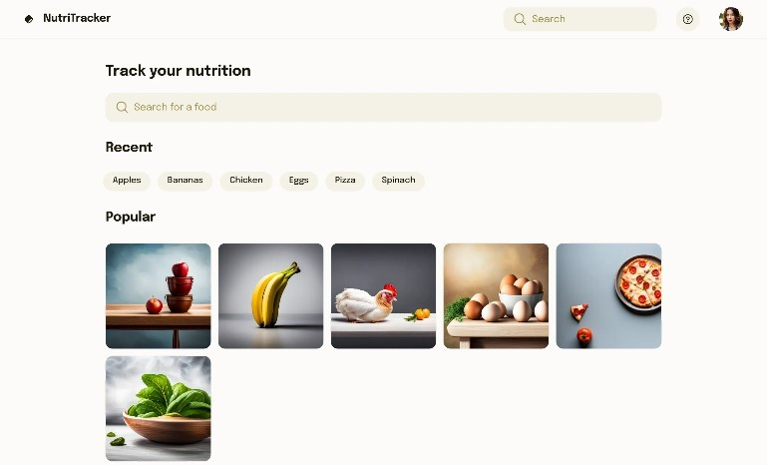

*Fig 3: Homepage of the website*

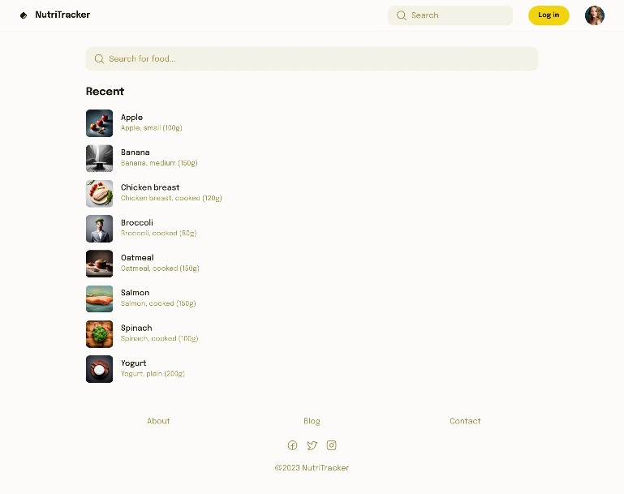

*Fig 4: Search page for the food items*

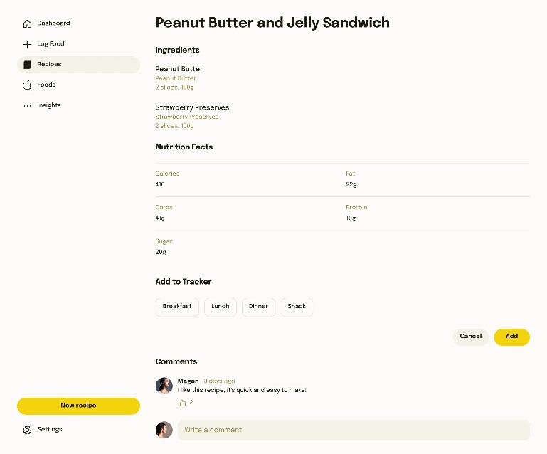

*Fig 5: Details of the selected food item*

# RESEARCH OBJECTIVE

The primary objective of this research project is to develop a web-based application that enables users to effectively monitor and manage their daily intake of essential vitamins and minerals. This goal aligns with addressing an identified gap in existing dietary applications, which often fail to provide comprehensive, personalized, and actionable insights on micronutrient intake.

The objectives of this research project are structured to ensure a well-rounded and practical approach to designing a micronutrient tracking application. These objectives are aligned with current nutritional science and digital health practices, supporting both health education and preventive healthcare. The following paragraphs elaborate on the key objectives that guide the development of this application:

* + 1. **Empower Users to Monitor Micronutrient Intake with Real-Time, Data-Driven Insights**

This application seeks to empower individuals to take control of their micronutrient intake through accurate, real-time insights derived from their daily food logs. By allowing users to track their intake of vitamins and minerals with ease, the application addresses the critical need for nutritional awareness in a fast- paced society. In recent years, research has shown that many individuals struggle to meet the recommended daily intakes of essential nutrients, which can lead to both acute deficiencies and long-term health complications. A key objective of this project is to help users make informed dietary decisions by displaying clear, understandable, and personalized data.

The use of data-driven insights offers a more dynamic and interactive approach to nutrition management than traditional methods. By leveraging this approach, the app encourages users to adopt healthier eating habits based on precise, personalized recommendations. The integration of external APIs provides a vast and continuously updated database of nutritional data, ensuring users receive accurate and relevant information. This is particularly important in the context of public health, where accurate tracking of vitamins like D, C, B12, and minerals like iron and calcium can prevent deficiency-related health issues, which are common in various populations worldwide.

* + 1. **Provide Personalized Recommendations Based on Dietary Patterns**

Personalization is at the heart of this project, as the application is designed to analyze users' individual dietary habits and generate recommendations tailored to their needs. Through consistent tracking, the application can detect patterns in nutrient consumption, identify areas of deficiency or excess, and suggest dietary adjustments accordingly. This feature distinguishes the app from general-purpose diet trackers, as it focuses specifically on micronutrient intake, which is often overlooked in mainstream diet applications.

The personalized recommendations feature leverages analytical algorithms and statistical modeling to provide actionable insights. For example, if a user is consistently low in iron intake, the application might suggest foods high in iron or flag this as a critical nutrient to watch. By encouraging nutrient-dense food choices over synthetic supplements where possible, the app also emphasizes whole food sources, promoting a more natural approach to nutrition. This objective is grounded in evidence showing that dietary recommendations tailored to an

individual’s specific nutrient needs are more likely to promote long-term adherence to healthy eating habits.

* + 1. **Integrate Advanced Data Visualization for Clear, Interactive Feedback**

One of the project’s primary objectives is to present nutritional data in an accessible and engaging manner through interactive data visualizations. Complex nutritional information can often be overwhelming, especially for users who are new to nutrition tracking. To make the data more understandable, the application includes real-time visualizations, such as pie charts, bar graphs, and trend analyses, to represent daily intake and nutrient progress over time.

The goal of these visualizations is to simplify data interpretation, enabling users to quickly assess whether they are meeting their daily requirements for essential vitamins and minerals. This feature enhances the user experience, as studies in health informatics have shown that visual feedback can improve understanding and retention of health information, leading to more effective behavior changes. By providing users with intuitive visual representations of their nutrient intake, the application seeks to make nutrition tracking a habit-forming activity that can support sustainable dietary improvements.

* + 1. **Enhance User Engagement through a Responsive and User- Friendly Interface**

A critical objective of this project is to ensure the application is easy to navigate, responsive, and compatible with multiple devices. The interface design is guided by user experience (UX) principles, aiming to create an engaging and interactive environment that encourages regular use. Given the diversity in users’ technical

proficiency, the website is designed to minimize cognitive load and simplify nutrient tracking, using a clean layout, intuitive navigation, and accessible language.

In the context of mobile health (mHealth) applications, usability plays a significant role in the adoption and effectiveness of health interventions. The interface is designed with React.js, which allows for the development of reusable components that enhance the user experience across various devices, including smartphones, tablets, and desktops. A focus on UX design also aligns with evidence indicating that individuals are more likely to continue using health applications if they are easy to use and visually appealing. This objective, therefore, ensures that the application is accessible to a wide audience and conducive to sustained engagement.

* + 1. **Promote Long-Term Health Awareness and Encourage Natural Nutrient Sources Over Supplements**

Another objective of the micronutrient tracking application is to promote a sustainable approach to health by emphasizing the benefits of whole foods over synthetic supplements. The application incorporates educational content and prompts users to achieve their nutrient goals through dietary sources whenever possible. For instance, if a user is deficient in vitamin C, the app might suggest incorporating more citrus fruits, bell peppers, or leafy greens rather than recommending a vitamin C supplement.

This objective is grounded in nutrition science, which increasingly advocates for nutrient-dense, whole foods as the primary source of vitamins and minerals. By helping users understand the nutritional value of various foods, the application aims to build long-term dietary awareness, encouraging users to make food choices

that contribute to holistic health. Research has shown that relying on whole foods, rather than supplements, can provide a more balanced nutrient profile and reduce the risk of overconsumption, making this objective particularly relevant for long- term wellness.

* + 1. **Ensure Data Privacy and Security Through Robust Authentication and Data Protection Measures**

In any health-related application, data privacy and security are paramount. The project includes objectives related to safeguarding user information and ensuring secure access to the application. This involves implementing robust authentication methods, such as JSON Web Tokens (JWT) and bcrypt hashing for password protection, to prevent unauthorized access. Additionally, the application stores user data in MongoDB, a secure, NoSQL database, ensuring that all sensitive information is managed according to best practices in data security.

By focusing on data privacy, the application aligns with legal and ethical standards, such as the Health Insurance Portability and Accountability Act (HIPAA) in the United States and the General Data Protection Regulation (GDPR) in the European Union. The project prioritizes user trust, recognizing that privacy concerns can be a barrier to the adoption of health applications. The objective is to reassure users that their data is protected, allowing them to engage with the platform without compromising personal information.

* + 1. **Explore Potential for Future Integration with Wearable Devices and Extended Health Analytics**

An additional forward-looking objective is to assess the potential for integrating wearable devices and expanding the application’s analytical capabilities. While the

initial development focuses on web-based tracking and API integration, the application architecture is designed to support future scalability. By exploring interoperability with wearables, such as fitness trackers or smartwatches, the project lays the groundwork for providing users with comprehensive health insights, including real-time monitoring of physical activity, hydration levels, and other biometrics.

Future integrations could enable the application to become a more holistic health management tool, combining micronutrient tracking with broader health indicators. This aligns with trends in digital health, where wearable technology and remote monitoring are becoming increasingly valuable for personalized healthcare. By setting this as a long-term objective, the project highlights its potential to grow beyond nutrient tracking, offering a more comprehensive platform for wellness management.

**CHAPTER 5:**

**FUTURE WORK AND CONCLUSION**

# FUTURE SCOPE

**Incorporating Medical Report Scanning and Advanced Recommendations**

The future of this micronutrient tracking website lies in expanding its functionality to incorporate advanced features, including the ability to scan and analyze medical reports. This enhancement would position the website as an even more valuable tool for personalized health management by integrating medical data to provide targeted dietary recommendations. Currently, the application allows users to track their daily vitamin and mineral intake and receive personalized recommendations based on dietary patterns. However, by integrating medical report analysis, the website can transform into a comprehensive health assistant, offering more nuanced insights tailored to users' unique medical profiles. This future direction aligns with advancements in health technology, machine learning, and natural language processing (NLP), creating a roadmap for a powerful and adaptable platform for nutritional and health management.

* + 1. **Integrating Optical Character Recognition (OCR) for Medical Report Scanning**

The first step in enabling medical report analysis is to implement Optical Character Recognition (OCR) technology. OCR allows the system to extract text from scanned medical reports or images, transforming handwritten or printed information into machine-readable data. This feature would let users upload their lab results, prescriptions, or other relevant documents directly into the platform.

OCR technology has already seen success in healthcare, where it is used to digitize medical records, improve data entry, and enhance accessibility of patient information. By integrating OCR, the website can read essential data such as vitamin levels, blood count, glucose levels, cholesterol levels, and other biochemical indicators. This allows the application to provide specific recommendations based on current health markers, such as suggesting higher iron intake for users with low haemoglobin or recommending vitamin D-rich foods for users with low vitamin D levels.

* + 1. **Applying Natural Language Processing (NLP) for Report Interpretation**

Once the OCR component extracts text data from medical reports, the next step is to interpret this information using Natural Language Processing (NLP) algorithms. NLP allows the system to understand medical terminology, interpret lab results, and identify health conditions mentioned in the report. For example, if a user’s report mentions “anaemia,” the system would recognize this condition and adjust dietary recommendations to include iron-rich foods.

Using NLP to interpret medical language is crucial for making sense of complex reports and converting them into actionable insights. NLP can analyze not only numerical values but also descriptive diagnoses, such as “borderline cholesterol” or “elevated blood sugar,” which could trigger specific dietary suggestions. NLP algorithms have been widely adopted in healthcare for tasks like electronic health record (EHR) analysis and clinical decision support, and their inclusion in this project could allow for more context-aware dietary recommendations tailored to individual health profiles.

* + 1. **Leveraging Machine Learning for Personalized Recommendations**

Once OCR and NLP extract and interpret data from medical reports, machine learning (ML) algorithms can enhance the accuracy of personalized recommendations. By analyzing historical data, dietary patterns, and health trends, ML models can predict which nutrients are likely to benefit the user based on their unique profile. For instance, an ML algorithm could determine that a user with recurring low calcium levels may benefit from calcium-rich foods, fortified foods, or supplements as part of their regular diet.

Machine learning can also enable predictive health insights. If the platform identifies patterns in a user's nutrient deficiencies or health markers over time, it can alert the user to potential risks, such as the likelihood of developing deficiencies or related health conditions. This proactive approach is valuable for preventive health, as it encourages users to address nutritional imbalances before they lead to more severe health issues.

* + 1. **Developing a Comprehensive Nutrient Deficiency Database**

To provide accurate recommendations based on medical reports, the website can incorporate a comprehensive database of nutrient deficiencies, health conditions, and corresponding dietary suggestions. This database would map out common conditions associated with nutrient deficiencies, such as osteoporosis linked to low calcium intake, anemia linked to iron deficiency, and cognitive decline associated with low vitamin B12. By referencing this database, the application can provide tailored recommendations in response to specific lab values or diagnostic information.

In addition, the nutrient database could also include alternative sources for users with dietary restrictions, allergies, or preferences (e.g., vegan or gluten-free options), making it easier for users to adhere to recommended dietary adjustments without compromising their personal dietary needs.

* + 1. **Expanding API Integrations for Real-Time Medical Data Retrieval**

As part of the future scope, the website could integrate with APIs that allow real-time retrieval of medical data from wearable devices, health platforms, and digital medical records. Such integrations could enable users to sync their health information directly to the platform, updating nutrient recommendations dynamically based on new data inputs.

For example, with wearable devices that track metrics like heart rate, sleep quality, and physical activity, the platform could tailor dietary recommendations based on lifestyle factors as well as medical data. This integration could also allow for continuous monitoring of health markers like blood pressure and glucose levels, making it possible to generate nutrient recommendations that respond to fluctuations in these indicators.

* + 1. **Establishing a Recommendation Engine for Tailored Dietary and Lifestyle Advice**

With OCR, NLP, machine learning, and API integration in place, the website can then implement an advanced recommendation engine. This engine would analyze all collected data—from user-submitted food logs to lab results and wearable data—to offer comprehensive and context-specific advice. For instance, if a user's medical report indicates high cholesterol, the recommendation engine

could suggest foods rich in omega-3 fatty acids, fibre, and antioxidants, while also advising against trans fats.

The recommendation engine could also cross-reference the user's dietary history with their medical records to identify gaps in nutrition that may exacerbate certain conditions. For instance, if a user with a family history of osteoporosis has low calcium intake, the platform could recommend not only calcium-rich foods but also vitamin D and weight-bearing exercises to support bone health.

* + 1. **Enhancing Preventive Health through Periodic Reports and Insights**

One of the most valuable features in the future scope is the generation of periodic health reports that provide users with a summary of their nutrient intake, medical history, and health trends over time. These reports could offer insights on nutrient sufficiency, highlight deficiencies, and recommend potential dietary changes. By receiving regular feedback on their health and nutrition, users are encouraged to make more informed choices and take a proactive role in their well- being.

The report feature could also serve as a valuable communication tool between users and their healthcare providers. For instance, users could bring their reports to doctor appointments to discuss their dietary intake and make adjustments based on professional advice. This feature aligns with the broader goal of preventive healthcare, allowing users to detect and address nutritional deficiencies before they lead to more serious health issues.

* + 1. **Ensuring User Privacy and Compliance with Data Protection Regulations**

With the expansion of features, including medical report scanning and personalized health recommendations, data privacy becomes increasingly critical. The platform would need to ensure compliance with healthcare data regulations such as the Health Insurance Portability and Accountability Act (HIPAA) in the United States or the General Data Protection Regulation (GDPR) in the European Union. The future scope of this project includes enhancing privacy protocols and ensuring secure data handling processes.

Encryption, secure data storage, and user consent protocols would be implemented to maintain data privacy. Additionally, allowing users to control what data they share or delete ensures transparency and builds trust in the platform. This emphasis on privacy helps establish the website as a reliable and secure resource for personal health management.

* + 1. **Expanding into Comprehensive Health and Wellness Management**

Beyond micronutrient tracking, the platform could evolve into a more holistic health and wellness management tool. Future features could include mental health tracking, hydration monitoring, and exercise logging. Integrating these aspects could provide a more complete picture of the user’s overall health and wellness, allowing for an even broader range of personalized recommendations. By incorporating modules for mental and physical wellness, the platform could address more facets of preventive health, helping users achieve a balanced lifestyle that encompasses diet, exercise, and mental well-being.

# CONCLUSION

In conclusion, the development of a micronutrient tracker website responds to a critical need for tools that promote better dietary management, especially in today’s fast-paced lifestyles where maintaining balanced nutrition is often a challenge. The research presented here demonstrates the potential of such a website to empower users by providing real-time tracking and personalized insights into their daily intake of essential vitamins, minerals, and other nutrients. By leveraging the MERN stack, the website was designed with a focus on user-friendliness, efficiency, and accuracy, enabling users to seamlessly monitor their dietary habits.

One of the core features of the website is the generation of personalized nutrient intake reports. These reports provide a clear, visual representation of daily micronutrient consumption, using data visualization tools like pie charts and graphs. This feature allows users to quickly identify whether they are meeting their nutritional goals, or if they have any deficiencies or excesses in specific nutrients. The reports are generated based on real-time data input by users, ensuring that the insights are tailored to each individual’s dietary habits. By offering this level of personalization, the website not only helps users track their food intake but also encourages them to make healthier choices based on their unique nutritional needs. Furthermore, the website’s integration with external nutrition APIs provides users with detailed information on the nutritional content of various foods. This functionality allows users to either input individual food items or submit entire custom recipes, which the website analyzes to deliver comprehensive breakdowns of both macronutrients (such as proteins, fats, and carbohydrates) and micronutrients (such as vitamins and minerals). By making this detailed information readily available, the website equips users with the knowledge needed to make informed dietary decisions,

supporting healthier eating habits over the long term. This app empowers users to make informed dietary choices by providing them with tailored recommendations based on their tracked data. This capability allows users to adjust their meals and snacks in real time to ensure they are meeting their nutritional goals, thus fostering a proactive approach to health management. For instance, the website can notify users if they are falling short of their daily recommended intake of certain vitamins or if they are consuming too much of a particular nutrient, prompting them to modify their diet accordingly.

The combination of personalized reports, detailed nutritional insights, and tailored recommendations creates a comprehensive system that supports users in maintaining a well-balanced diet. It also enhances user engagement by providing actionable feedback and motivating healthier eating behaviours. Through the combination of cutting-edge technology and evidence-based nutritional insights, the website bridges the gap between dietary habits and nutritional health, empowering users to take control of their wellness. Looking forward, future improvements to the website could include expanding the food database to cover more region-specific ingredients and enhancing the accuracy of the custom recipe analysis. These refinements would further boost the website's utility, making it even more comprehensive and reliable for users from diverse cultural and dietary backgrounds. Additionally, integrating machine learning models for predictive analysis could enable the app to forecast users’ dietary needs based on historical data, adding another layer of personalization to the user experience.

This micronutrient tracker website demonstrates the immense potential of digital health tools to positively influence dietary habits, making it easier for individuals to lead healthier, more informed lives.

**REFERENCES**

A. Scarry, J. Rice, E. M. O’Connor, and A. C. Tierney, “Usage of

1] mobile websites or mobile health technology to improve diet quality in adults,” *Nutrients*, vol. 14, no. 12, p. 2437, 2022.

D. P. Ghelani et al., "Mobile apps for weight management: A review of 2] the latest evidence to inform practice," Frontiers in Endocrinology, vol.

11, p. 412, 2020.

C. Media, “Cronometer adds immunity and women’s health to 3] micronutrient tracking app,” .*nutritioninsight.com/*, 07-Apr-2021

G. Ferrara, J. Kim, S. Lin, J. Hua, and E. Seto, “A focused review of 4] smartphone diet-tracking apps: Usability, functionality, coherence with

behavior change theory, and comparative validity of nutrient intake and energy estimates,” *JMIR MHealth UHealth*, vol. 7, no. 5, p. e9232, 2019.

S. Samad *et al.*, “Smartphone apps for tracking food consumption and 5] recommendations: Evaluating artificial intelligence-based

functionalities, features and quality of current apps,” *Intelligent Systems with Websites*, vol. 15, p. 200103, Sep. 2022, doi: https://doi.org/10.1016/j.iswa.2022.200103.

D. Bajaj *et al.*, “Android based nutritional intake tracking website for 6] handheld systems,” Jul. 2017, doi:

https://doi.org/10.1109/icccnt.2017.8203977.

M. Garcia, J. Mangaba, and A. Vinluan, “Towards the Development of a Personalized Nutrition Knowledge-Based System: A Mixed- Methods

7] Needs Analysis of Virtual Dietitian.” Accessed: Oct. 20, 2024.

CNS Media. & CNS MEDIA. (2021, April 7). Cronometer adds 8] immunity and women’s health to micronutrient tracking app.

*https://*[*www.nutritioninsight.com*.](http://www.nutritioninsight.com/) https://[www.nutritioninsight.com/news/cronometer-adds-immunity-and-](http://www.nutritioninsight.com/news/cronometer-adds-immunity-and-) womens-health-to-micronutrient-tracking-app.html